INFORMATION VISUALIZATION FALL 2017

FINAL PROJECT

<Student Name>

<Student ID>

**Sketches**

=> Add pictures of your sketches here (make sure they are legible!).

**Discussion**

=> Discuss advantages and disadvantages of your sketches, explain which one you have chosen and why.

Line Chart/ Stacked area chart

HeatMap – for change in ratings

Heat map for reviews (positive/negative) – divergent colors

Line chart for each category

**Implementation**

=> Add a picture of your final solution (make sure the graphic can be interpreted! Add a title, legend, axes, labels, etc.).

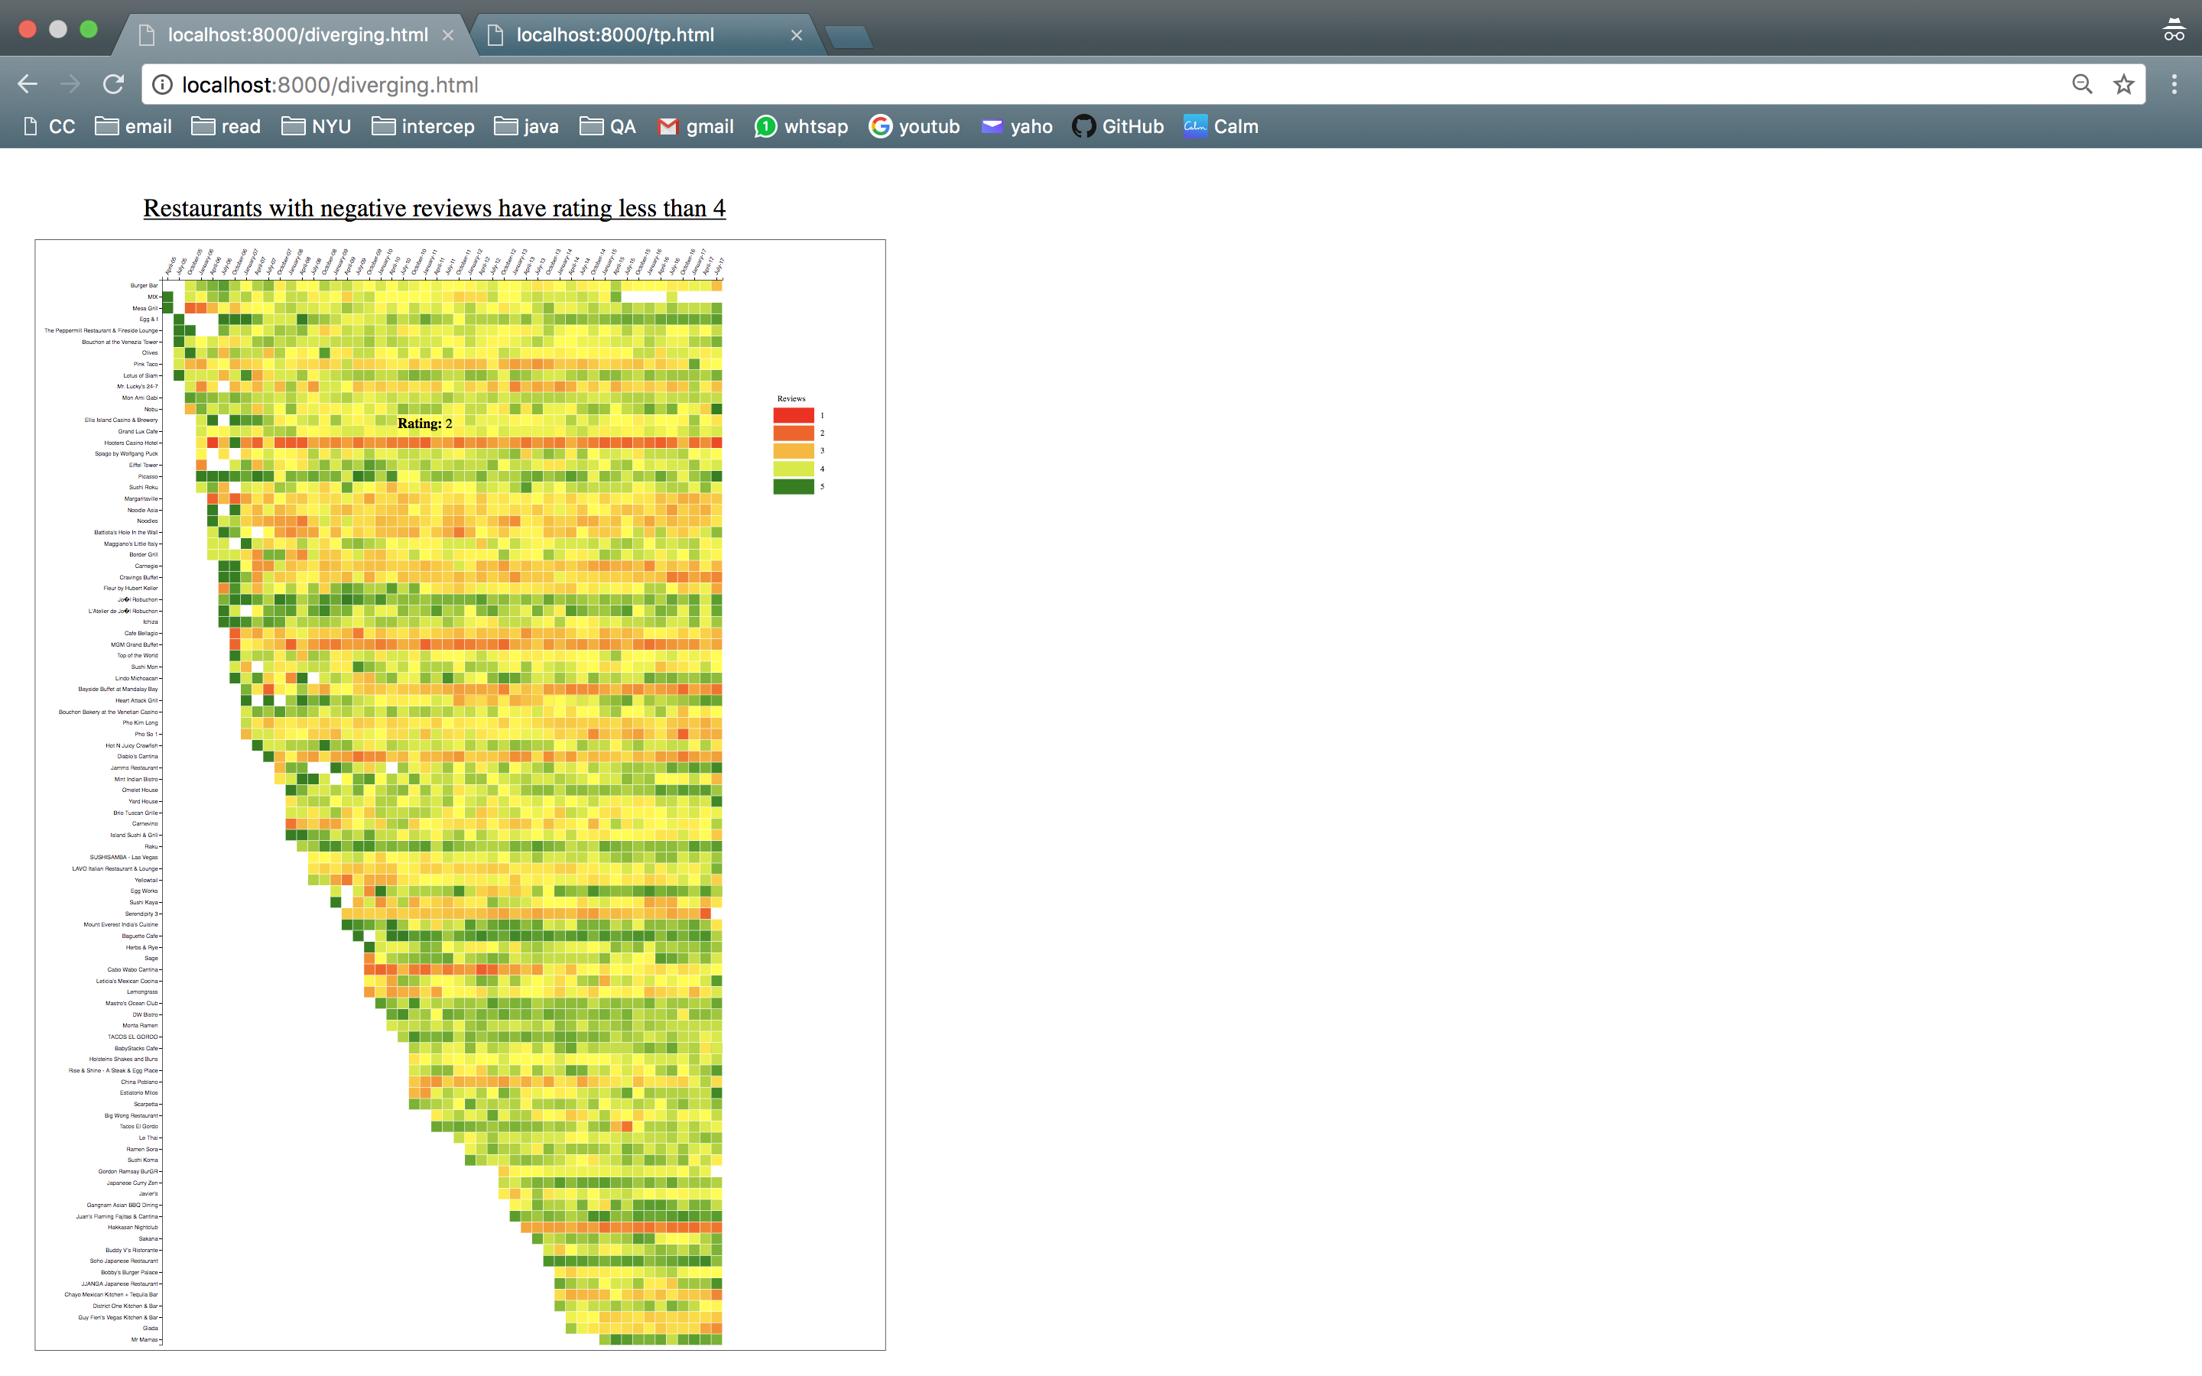

**Challenges and changes**

=> Discuss how the implementation differs from the initial sketch, what you had to change and challenges you had to overcome in the implementation.

=> If you had to implement multiple versions in D3 before creating the final one. also add pictures of the evolution of your design/implementation.

**Data Analysis Question 1: “Are there restaurants that have consistently negative reviews?”**

=> Add an answer to this question. If you have identified some restaurants, add a version of your visualization which shows/highlights restaurants that have consistently positive or negative reviews. Include labels that show the names of these restaurants.



**Data Analysis Question 2: Are there restaurants for which in some time periods their rating drops considerably?**

=> Add an answer to this question. If you have identified some restaurants. Add a version of your visualization which shows/highlights restaurants for which in some time periods their rating drops considerably. Include labels that show the names of these restaurants.

